**Depression Detection**

In this project we are detecting depression from users post, user can upload post in the form of text file, image file or audio file, this project can help peoples who are in depression by sending motivated messages to them. Now-a-days peoples are using online post services to interact with each other compare to human to human interaction. So by analysing users post this application can detect depression and send motivation messages to them. Administrator of this application will send motivation messages to all peoples who are in depression. To detect depression we are using SVM (support vector machine) algorithm which analyse users post and give result as negative or positive. If users express depression words in post then SVM detect it as a negative post else positive post.

To implement this project we are using python Speech Recognition API which will read text from audio files and then SVM will analyse that text to detect depression, user can also upload images via post and python Tesseract OCR (Optical Character Recognition) API can read text from uploaded image and then SVM will detect depression from that text, User can upload post in text file also.

Modules

Admin Module: Administrator will login to application using username as ‘admin’ and password ‘admin’. After login admin can view all registered users and all posts send by each users. Admin can send motivation messages to all depressed users. All positive and negative depression users can also be seen in the form of graph.

User Module: Users need to register with the application and then login to application to access various sub modules such as

Search Friends: Using this module user can see all peoples register with the application

Upload Posts: Using this module user can upload post in various formats such as text file, image or audio file. This application accepts only .WAV file format.

View Motivation Messages: Using this module users can view all motivation messages send by administrator.

Technologies used in this project

Programming Language : Python 3.7

Web Server : DJANGO

Database : MYSQL

Web Technologies : HTML, CSS, Java Scripts

Below are software packages we need to install after installing python

install ‘tesseract-ocr-setup-3.02.02’ (this software u can find inside code folder) software in C directory and then set path for tesseract-ocr-setup-3.02.02 file using below environment variable under system tab

Variable name : tesseract

Variable value = C:\Tesseract-OCR\tesseract.exe

Install below softwares using PIP command

pip install pytesseract

pip install SpeechRecognition

pip install Django

now create database in MYSQL by copying content from ‘DB.txt’ file and paste in mysql.

Now deploy code in DJANGO and start server and run in browser to get below screen

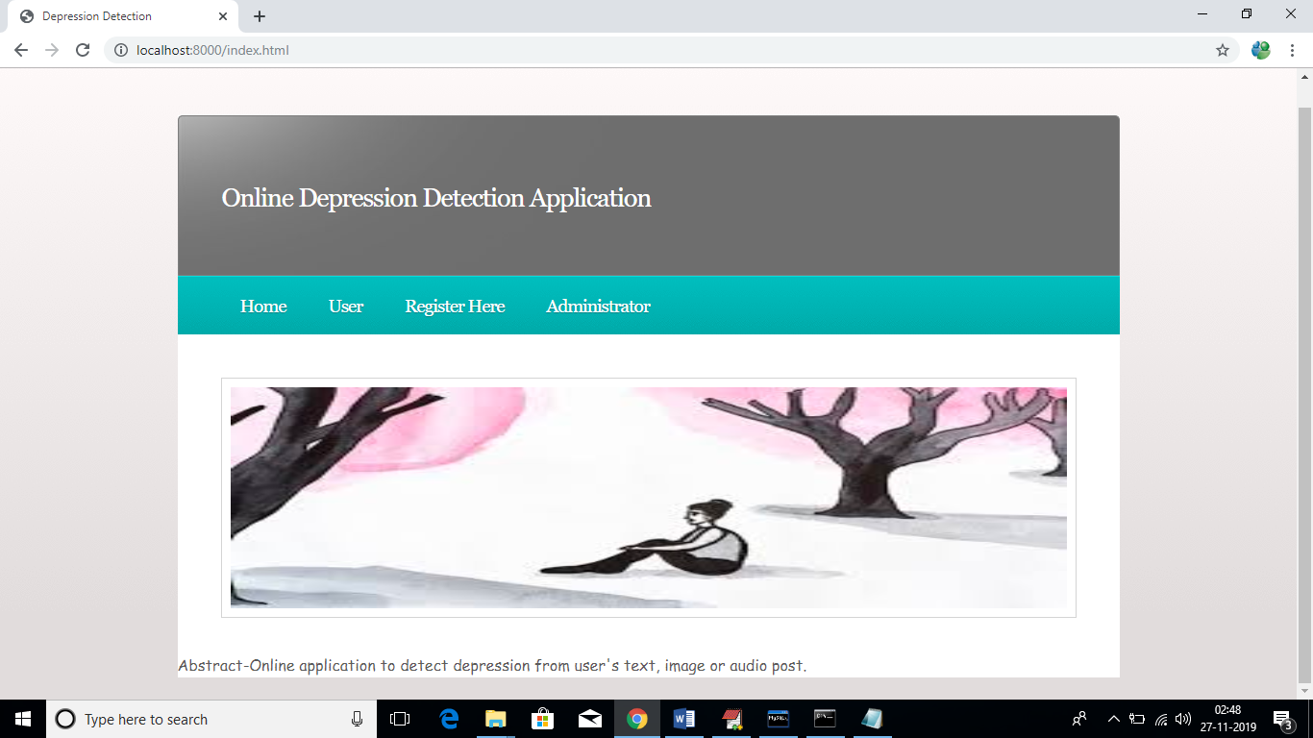

In above screen click on ‘Register Here’ link to add new user to application

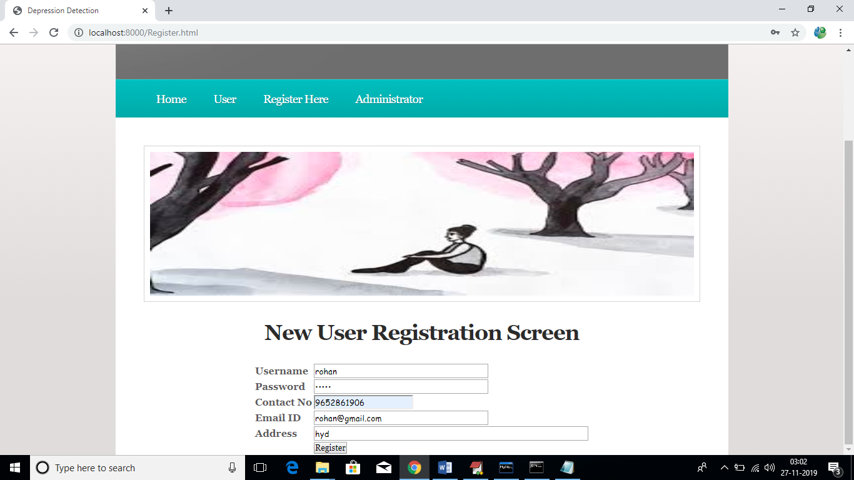

After register will get below confirmation screen

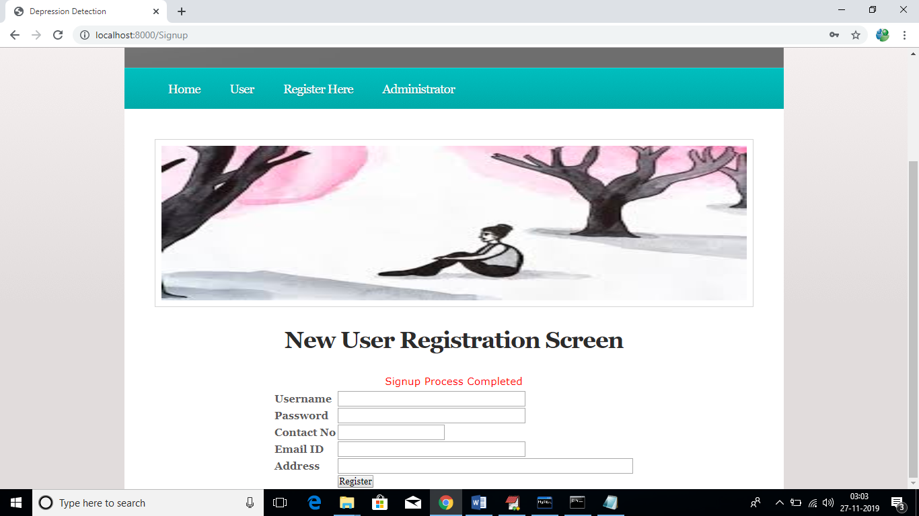

Now click on ‘User’ link to login as ‘user’

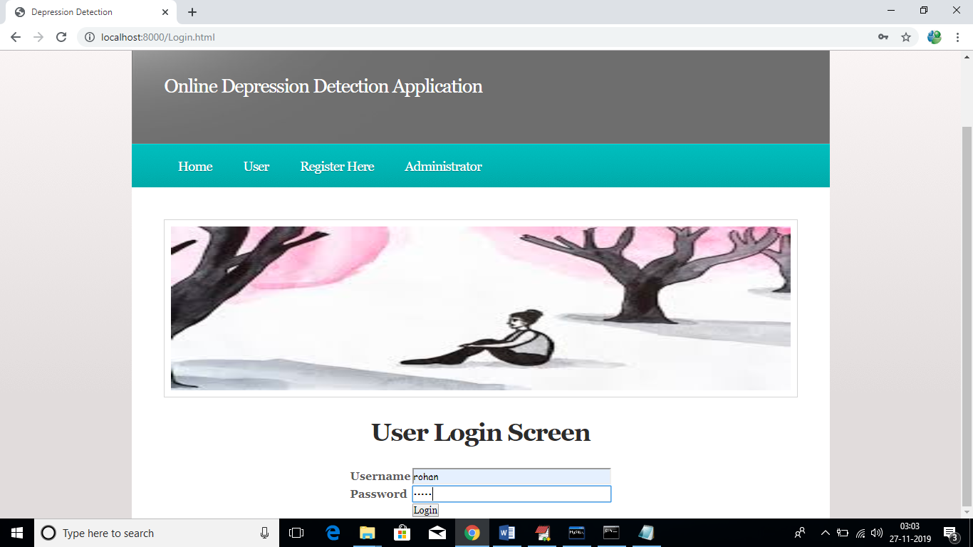

After login will get below user screen

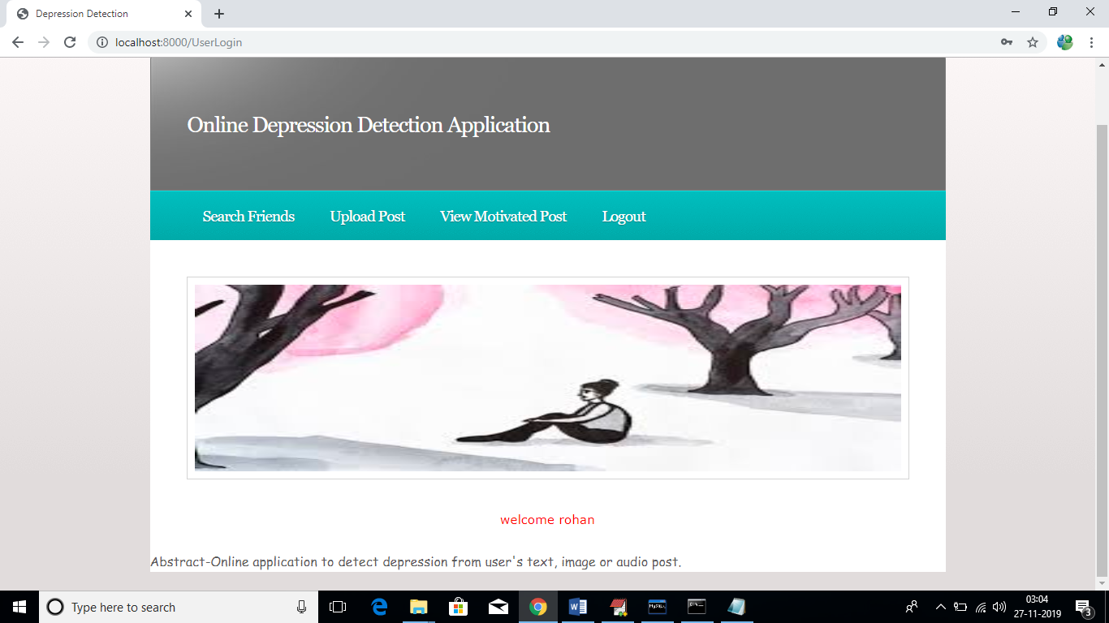

In above screen click on ‘Search Friends’ link to view all users registered with the application

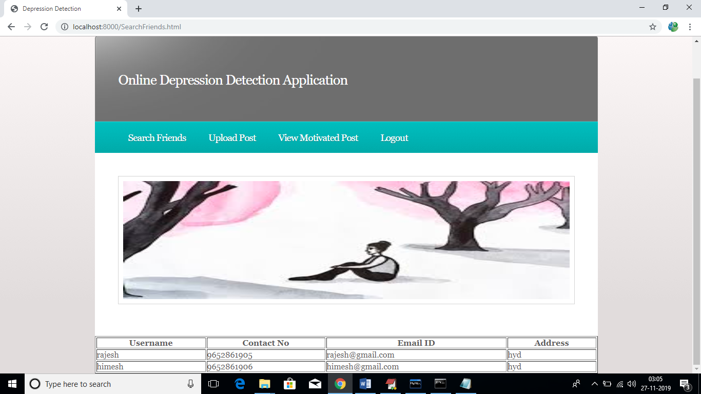

Now click on ‘Upload Post’ link to upload post files such as text, image or audio

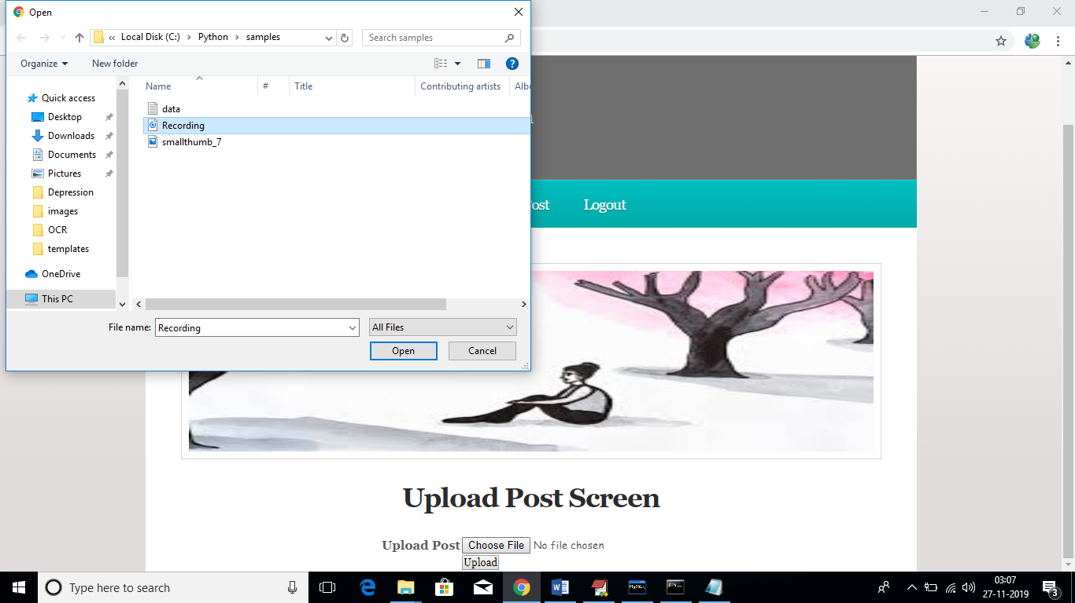

In above screen I am uploading one recording file, after upload will get below message from recording data

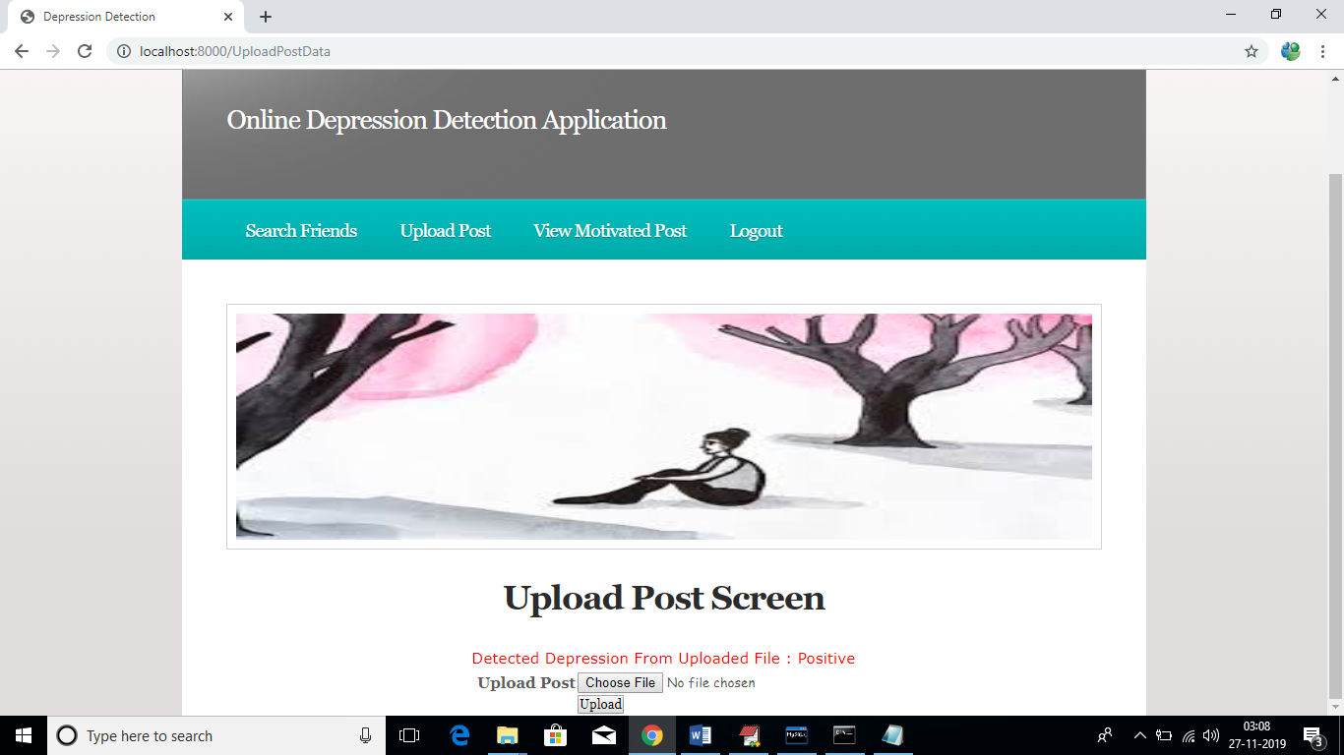

In above screen its says uploaded file contains message which indicate user is happy and gave positive recording. In below screen I am uploading one image which contains depress negative message

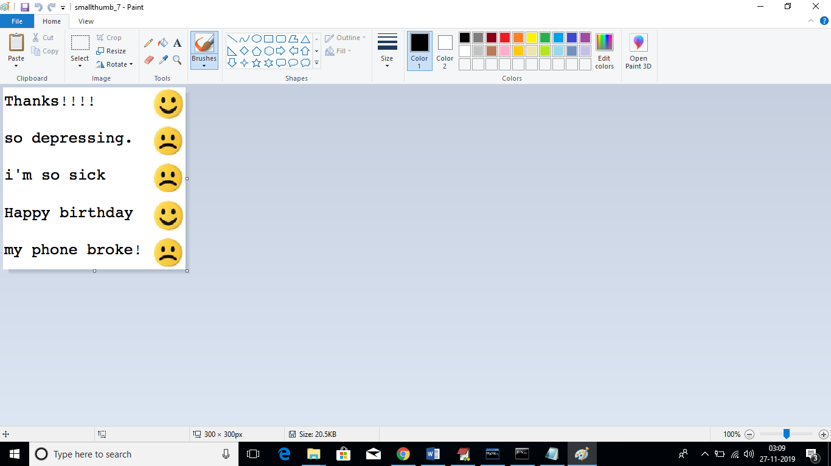

In above screen in title image file name is ‘smallthumb-7’ and it contains depress negative message and I will upload same image to application and see results

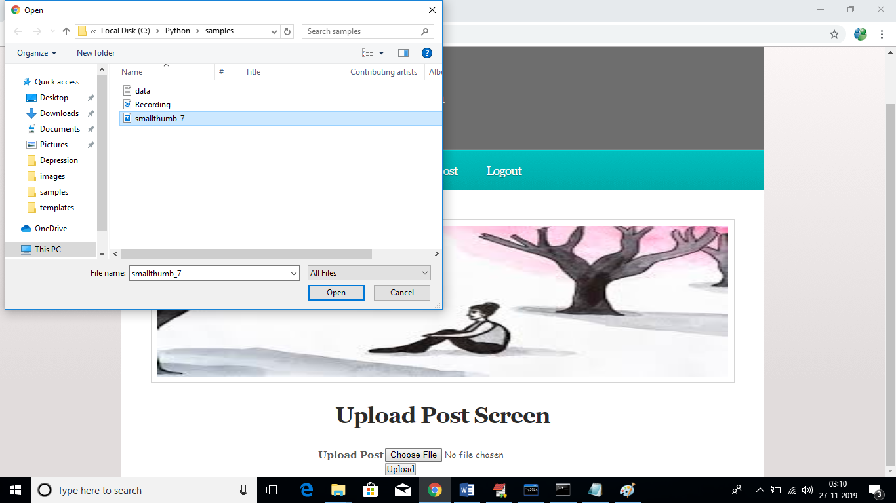

In above screen we can see I am uploading same image and below are is the output screen

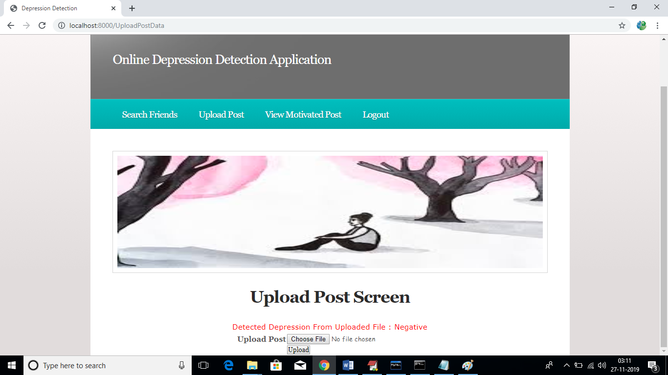

In above screen message is negative and we can say user is depressed. Similarly click on ‘View Motivated Post’ link to get admin message if he posted otherwise message will mark as ‘Pending’

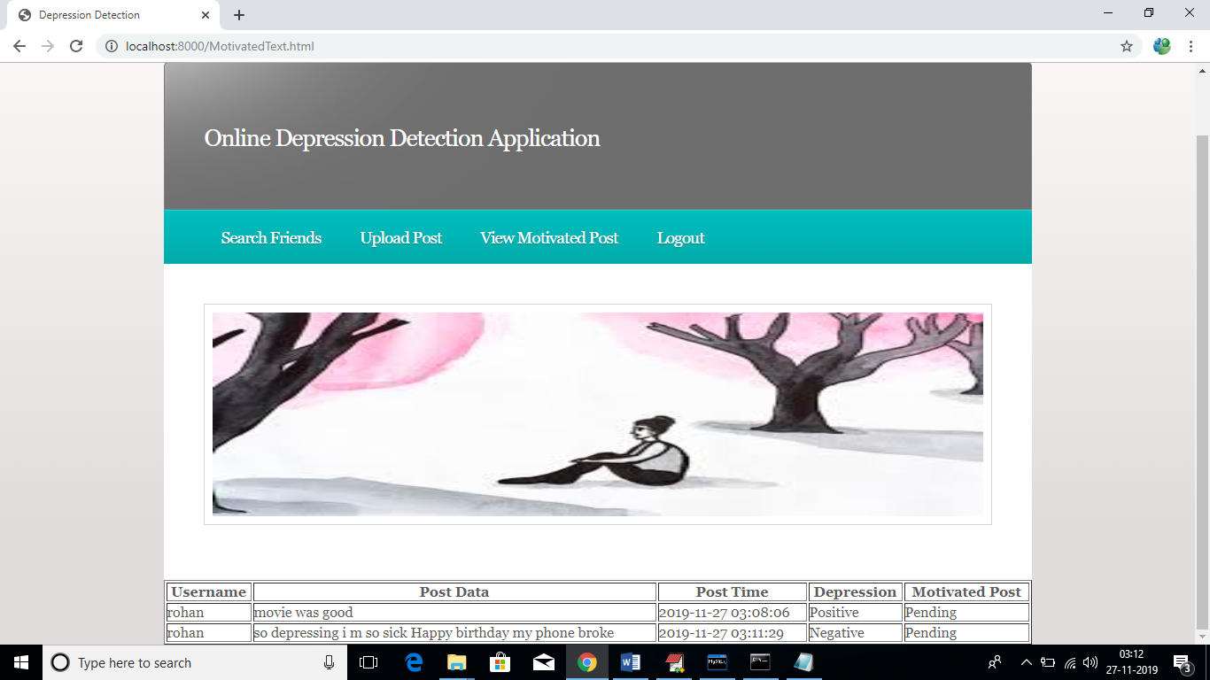

In above screen we can see this user uploaded two files one is recording and other one is image and both file data we can see as post data column and depression result as positive or negative also we can see. Admin has not sent any motivated post so the field is marked as ‘Pending’. Now logout and login as ‘admin’.

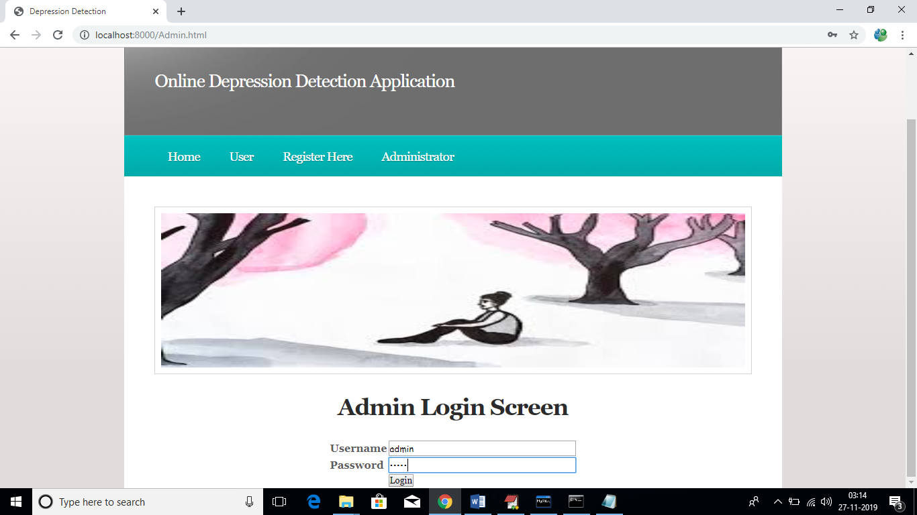

After login we can get below admin screen

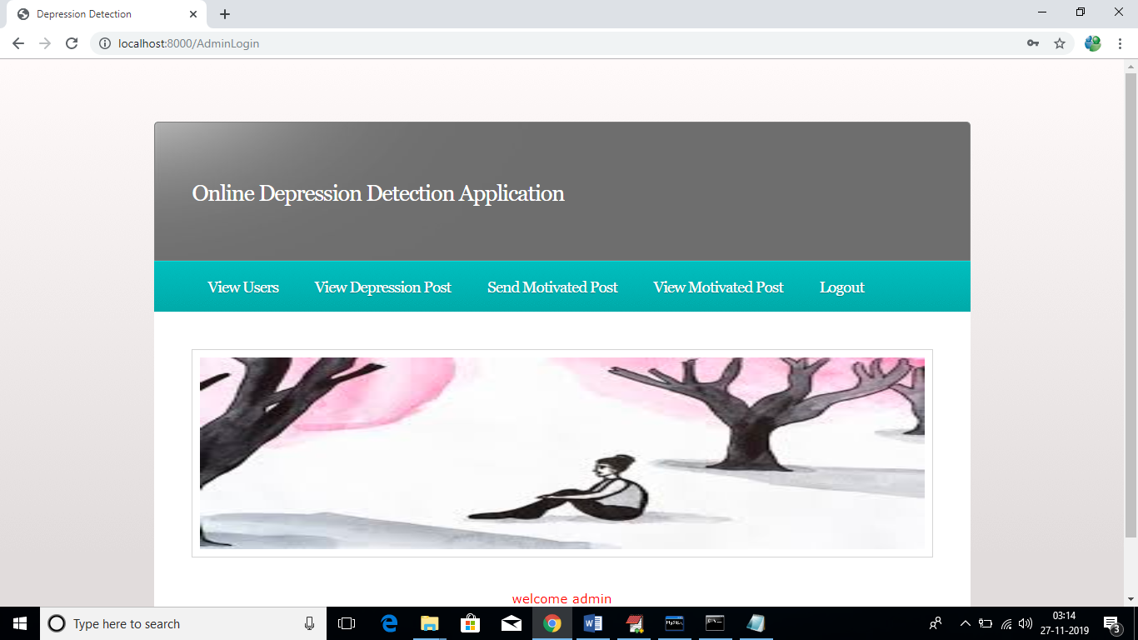

In above screen admin can click on ‘View Users’ to view all users list

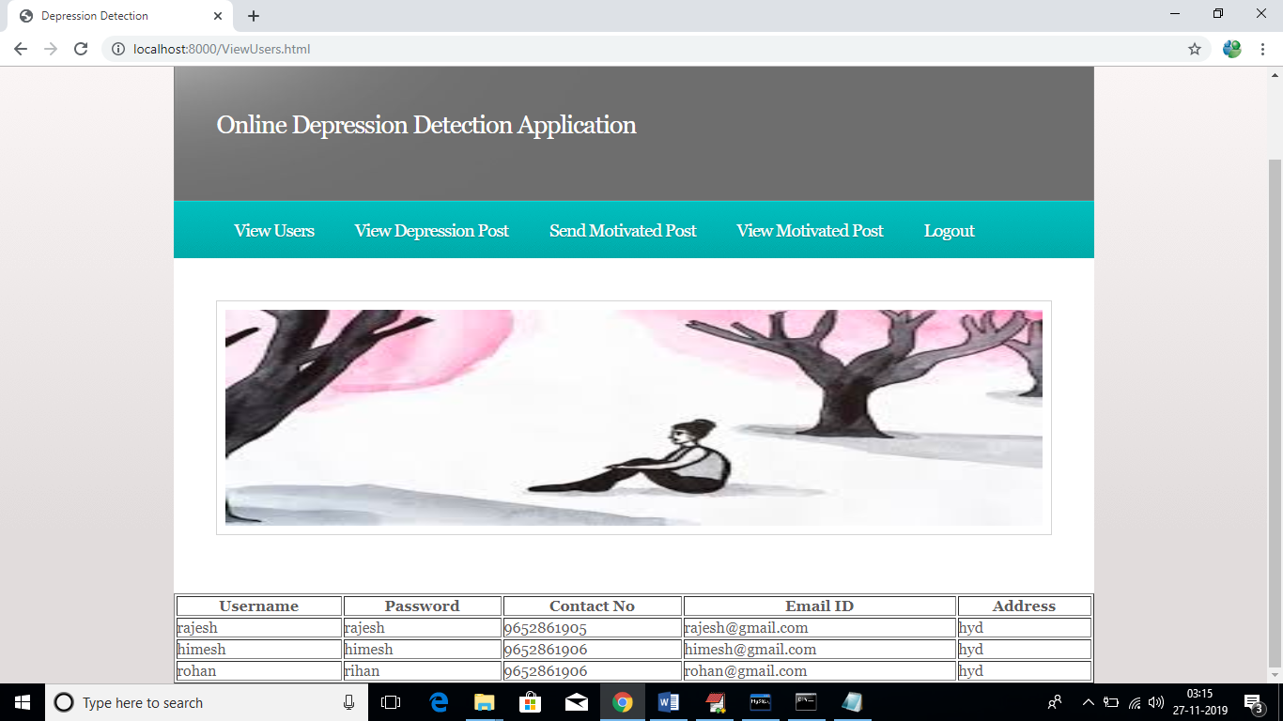

Similarly admin can click on ‘View Depression Post’ to view all post in graph and text format

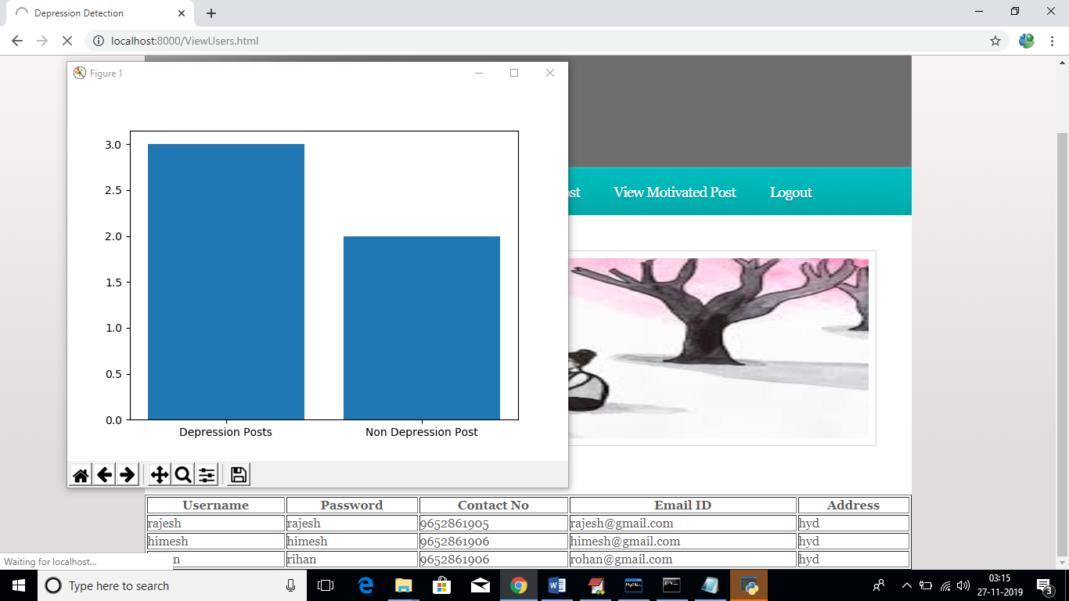

In above graph we can see total depress and non-depress users, see below screen for all posts from all users

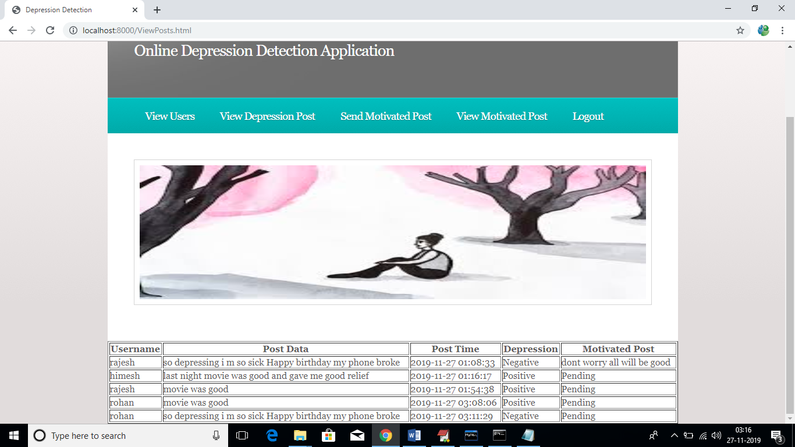

Similarly admin can click on ‘Send Motivated Post’ link to send motivated messages to users. While sending messages admin has to enter username and post time. Post time he can copy from above screen

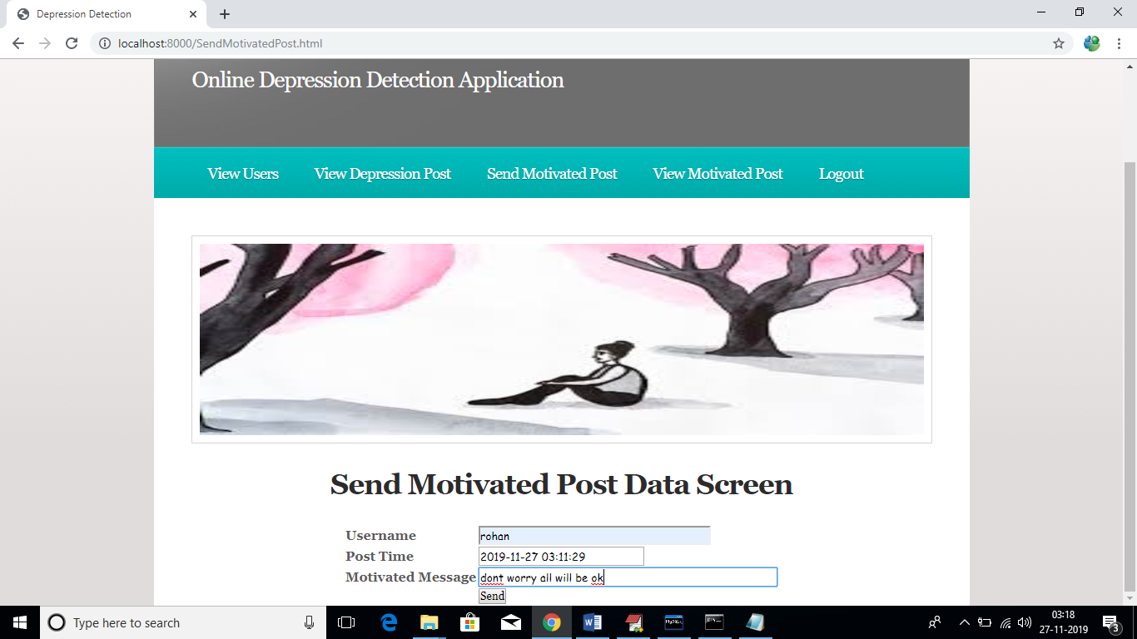

After sending motivated messages will get below screen

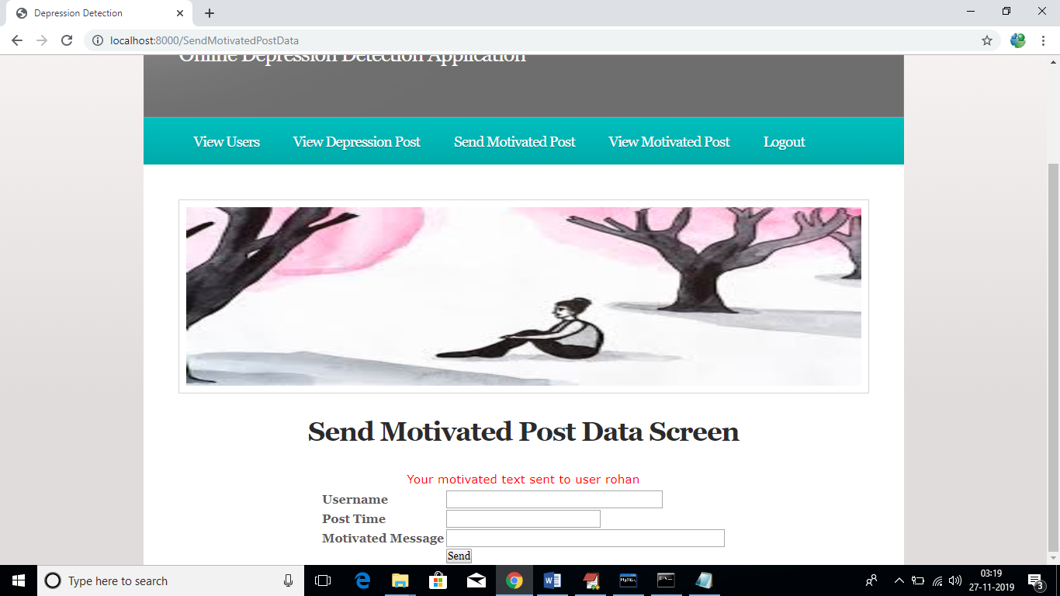

Now admin can click on ‘View Motivated Post’ link to view all motivated messages sent by him

